Git Repo URL:

<https://github.com/JohnChris5/OnlineShopping>

Git Branch:

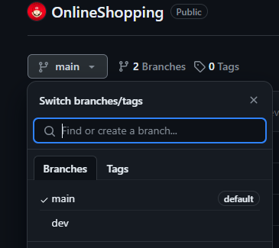

Deployed site URL:

<http://35.154.50.148/> (prod url)

<http://35.154.50.148:8080> (dev url)

Grafana site URL:

<http://35.154.50.148:3000/login>

UN: admin

Pw: Naruto

Grafana Dashboard url: http://35.154.50.148:3000/d/fdf4u8efcsu80c/project-guvi?orgId=1

Docker:

<https://hub.docker.com/repository/docker/johnchris5/dev/general> (dev public url)

docker pull johnchris5/dev:latest

docker pull johnchris5/prod:latest

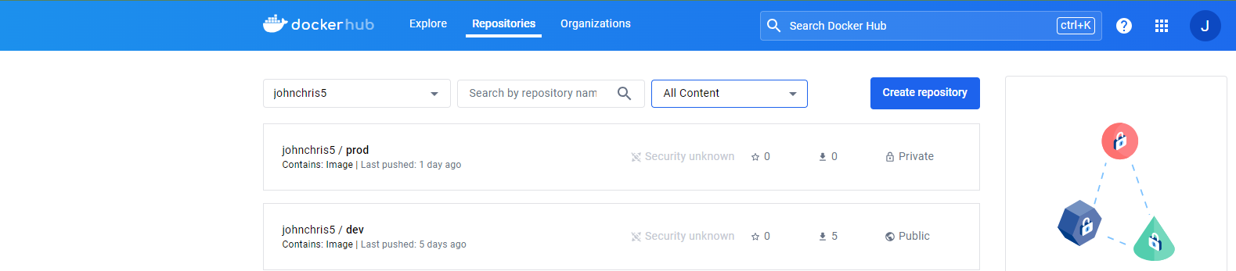

Ngrok:

Jenkins configured in local machine, Git hub webhook not able to reach the local machine so I have bypassed the issue using ngrok

Command for ngrok:

ngrok http --domain=mature-strong-caribou.ngrok-free.app 8080 > /dev/null &

\*\*\*\*All configuration and results snap added in Guvi-Project folder\*\*\*\*\*